
Facilitator Guide

Module 8 – Machine Learning
Occupational Certificate: Artificial Intelligence Software Developer

Module # | 251201-002-00-KM-08
NQF Level | 5
Notional hours | 160
Credit(s) | 16
Curriculum Code | 251201002
Qualification Title | Occupational Certificate: Artificial Intelligence Software Developer

CONTACT INFORMATION:
Name
Contact Address
Telephone (H)
Telephone (W)
Cellular

PURPOSE OF THE KNOWLEDGE MODULE
The main focus of the learning in this knowledge module is to build an understanding of the relationship between Artificial Intelligence, Machine Learning and Deep Learning, as well as the application of ML to create a set of instructions to perform a programming task

PROVIDER ACCREDITATION REQUIREMENTS FOR THE MODULE:

Physical Requirements:
- The provider must have lesson plans and structured learning material or provide learners with access to structured learning material that addresses all the topics in all the knowledge modules as well as the applied knowledge in the practical skills.
- QCTO/ MICT SETA requirements
Human Resource Requirements:
- Lecturer/learner ratio of 1:20 (Maximum)
- Qualification of lecturer (SME):
- NQF 6 in industry recognised qualifications with 1 year’s experience in the IT industry
- AI vendor certification (where applicable)
- Assessors and moderators: accredited by the MICT SETA
Legal Requirements:
- Legal (product) licences to use the software for learning and training (where applicable)
- OHS compliance certificate
- Ethical clearance (where necessary)
Exemptions
- No exemptions, but the module can be achieved in full through a normal RPL process

TOPIC ELEMENTS TO BE COVERED INCLUDE:
- KM-08-KT01 : Types of ML models
- KM-08-KT02 : ML algorithm classification
- KM-08-KT03 : Common ML algorithms
- KM-08-KT04 : ML Workflow Process (Framework)
- KM-08-KT05 : Business benefits of ML

SECTION 1: KM-08-KT01: Types of ML models

Explain the regression model and classification model?

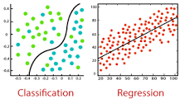

The main difference between Regression and Classification algorithms that Regression algorithms are used to predict the continuous values such as price, salary, age, etc. and Classification algorithms are used to predict/Classify the discrete values such as Male or Female, True or False, Spam or Not Spam, etc.

Identify the feature extraction in ML?

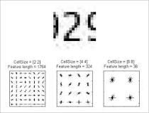

Feature extraction for machine learning and deep learning. Feature extraction refers to the process of transforming raw data into numerical features that can be processed while preserving the information in the original data set. It yields better results than applying machine learning directly to the raw data.

SECTION 2: KM-08-KT02:ML algorithm classification

Why is classification a supervised machine learning algorithm?

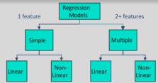

Supervised learning requires that the data used to train the algorithm is already labeled with correct answers. For example, a classification algorithm will learn to identify animals after being trained on a dataset of images that are properly labeled with the species of the animal and some identifying characteristics.

SECTION 3: KM-08-KT03: Common ML algorithms

What is k-means clustering and how it works?

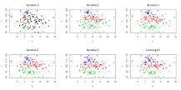

K-means clustering uses “centroids”, K different randomly-initiated points in the data, and assigns every data point to the nearest centroid. After every point has been assigned, the centroid is moved to the average of all of the points assigned to it.

Giving examples explain the reinforcement learning?

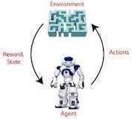

Hence, we can say that "Reinforcement learning is a type of machine learning method where an intelligent agent (computer program) interacts with the environment and learns to act within that." How a Robotic dog learns the movement of his arms is an example of Reinforcement learning.

SECTION 4: KM-08-KT04:ML Workflow Process (Framework)

Identify the data collection methods?
7 Data Collection Methods Used in Business Analytics
- Surveys. Surveys are physical or digital questionnaires that gather both qualitative and quantitative data from subjects. ...
- Transactional Tracking. ...
- Interviews and Focus Groups. ...
- Observation. ...
- Online Tracking. ...
- Forms. ...
- Social Media Monitoring.

How does AI collect your data?
Artificial intelligence can give you analytics superpowers. AI is a collection of technologies that excel at extracting insights and patterns from large sets of data. AI can use those insights and patterns to make predictions about what drives outcomes. It can even learn to improve its predictions over time.

Explain the data preparation process?



Data preparation is the process of collecting, cleaning, and consolidating data into one file or data table, primarily for use in analysis.

Why is data preparation necessary in machine learning?
This is because of reasons such as: Machine learning algorithms require data to be numbers. Some machine learning algorithms impose requirements on the data. Statistical noise and errors in the data may need to be corrected.

What is model in machine learning?

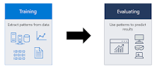

A machine learning model is a file that has been trained to recognize certain types of patterns. You train a model over a set of data, providing it an algorithm that it can use to reason over and learn from those data.

Why Evaluation is necessary for successful model?
Overfitting and underfitting are the two biggest causes for poor performance of machine learning algorithms.
Overfitting: Occurs when the Model performs well for a particular set of data(Known Data), and may therefore fail to fit additional data(Unknown Data) or predict future observations reliably.
Underfitting: Occurs when the model cannot adequately capture the underlying structure of the data.
Generalization: refers to how well the concepts learned by a machine learning model apply to specific examples not seen by the model when it was learning.
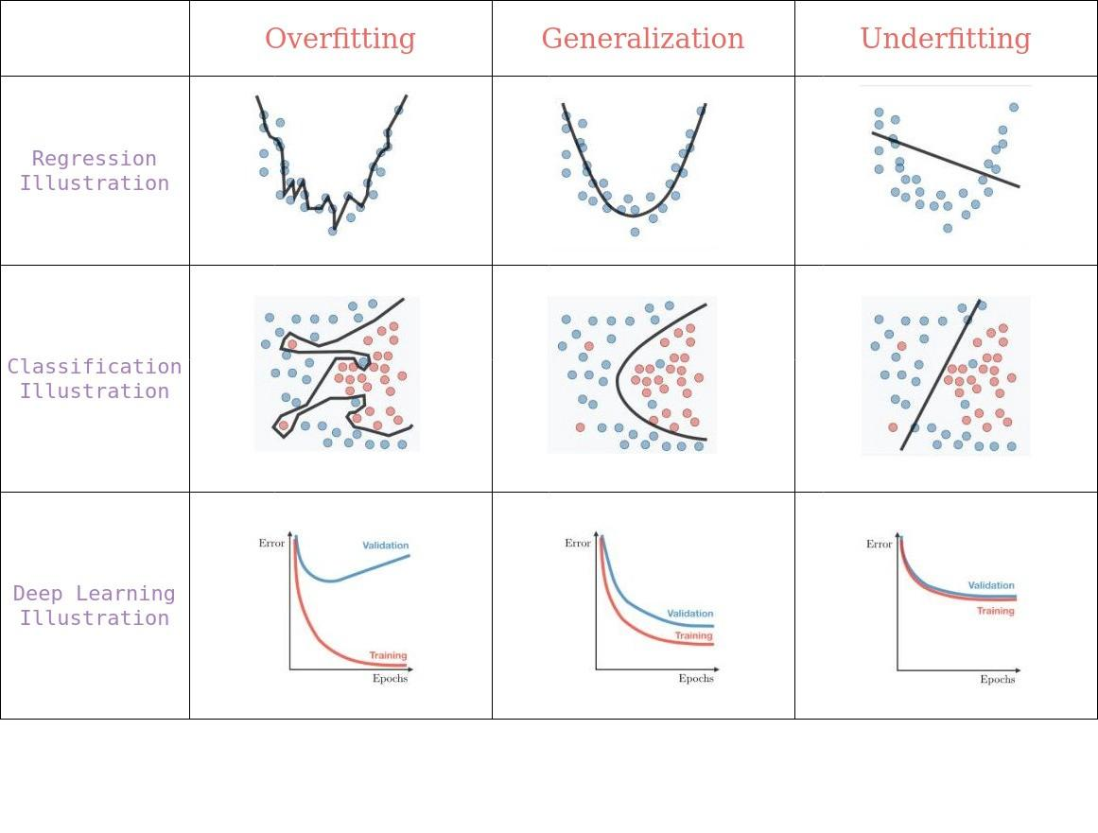
Overfitting vs Generalization vs Underfitting
In machine learning the learning of the target function from training data is described as inductive learning.Induction refers to learning general concepts from specific examples which is exactly the problem that supervised machine learning model aim to solve

Why do we do parameter tuning?
Hyperparameters tuning is crucial as they control the overall behavior of a machine learning model. Every machine learning models will have different hyperparameters that can be set. A hyperparameter is a parameter whose value is set before the learning process begins.

Explain the tuning in machine learning?
Tuning is the process of maximizing a model's performance without overfitting or creating too high of a variance. In machine learning, this is accomplished by selecting appropriate “hyperparameters.” Hyperparameters can be thought of as the “dials” or “knobs” of a machine learning model.

SECTION 5: KM-08-KT05 : Business benefits of ML 20%

What is real time decision-making?
Real-Time Decision-Making is the ability to deliver decision support within the shortest possible time-frame using the best possible set of data and decision-making model to direct and report on business operations and interactions.

Why is machine learning important in today's business environment?
Data is the lifeblood of all business. Data-driven decisions increasingly make the difference between keeping up with competition or falling further behind. Machine learning can be the key to unlocking the value of corporate and customer data and enacting decisions that keep a company ahead of the competition.

Explain the reduction of costs good for a business?
By cutting down your business costs, you can immediately increase profitability (and be smug about it too). Increasing profitability is a vital step in facilitating the growth of any business, but the task can seem impossible when faced with sales that just seem to plateau.

Why is machine learning so important for businesses?
Manufacturing – Machine learning helps manufacturers reduce process-driven losses, increase capacity by optimizing the production process, and reduce costs by guiding predictive maintenance.

